# **Creating Events in CloudWatch**

# **Lab Steps**

## **Task 1: Sign in to AWS Management Console**

1. Click on the **Open Console** button, and you will get redirected to AWS Console in a new browser tab.
2. On the AWS sign-in page,

Leave the Account ID as default. Never edit/remove the 12-digit Account ID present in the AWS Console. Otherwise, you cannot proceed with the lab.

Now copy your **Username** and **Password** in the Lab Console to the **IAM Username and Password** in AWS Console and click on the **Sign-in** button.

1. Once Signed In to the AWS Management Console, make the default AWS Region as **US East (N. Virginia) us-east-1.**

**Note :** If you face any issues, please go through [**FAQs and Troubleshooting for Labs**](https://www.whizlabs.com/labs/support-document/faqs-and-troubleshooting).

## **Task 2: Launching an EC2 Instance**

This EC2 Instance will be used for checking various features in CloudWatch.

1. Make sure you are in the **US East (N. Virginia) us-east-1** Region.
2. Navigate to **EC2** by clicking on the **Services** menu at the top, then click on **EC2** in the **Compute** section.
3. Navigate to **Instances** on the left panel and click on **Launch instances** button.

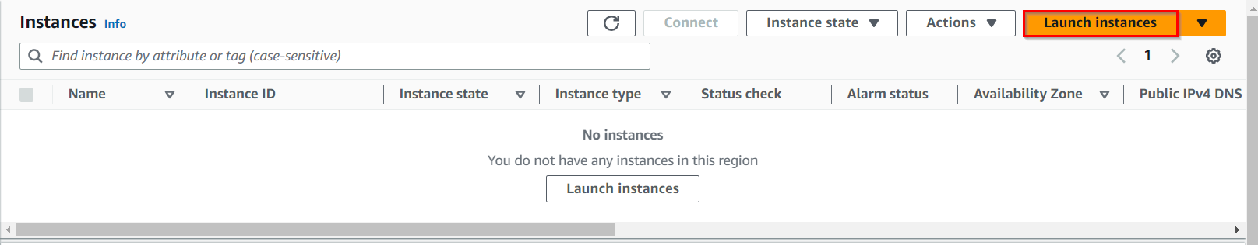

1. Name : Enter **MyEC2Server**

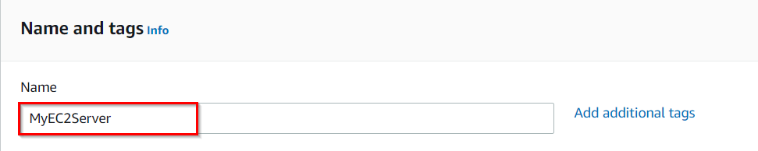

1. **For Amazon Machine Image (AMI):** Search for **Amazon Linux AMI** in the **Quick Search** menu.
2. **For Instance Type**: select **t2.micro**



1. **For Key pair:** Select **Create a new key pair** Button

Key pair name: **WhizKey**

Key pair type: **RSA**

Private key file format: **.pem**

1. Select **Create key pair** Button.
2. In Network Settings, Click on **Edit**:

Auto-assign public IP: **Enable**

Select **Create new Security group**

Security group name : Enter **MyEC2Server_SG**

Description : Enter **Security Group to allow traffic to EC2**

**To add SSH:**

Choose Type**: SSH**

Source : Select **Anywhere**

1. Keep rest thing Default and Click on **Launch Instance** Button.
2. Select **View all Instances** to View the Instance you Created
3. **Launch Status:** Your instances are now launching, Navigate to **Instances** page from left menu and wait the status of the EC2 Instance changes to running



1. Note the **Instance-ID** of the EC2 instance.

## **Task 3: Create SNS Topic**

In this task, we are going to create an SNS topic, which acts as a communication channel for sending notifications to subscribers.

1. Navigate to **Simple Notification Service** by clicking on the **Services** menu available under the **Application Integration** section.
2. Click on **Topics** in the left panel and click on **Create Topic** button.

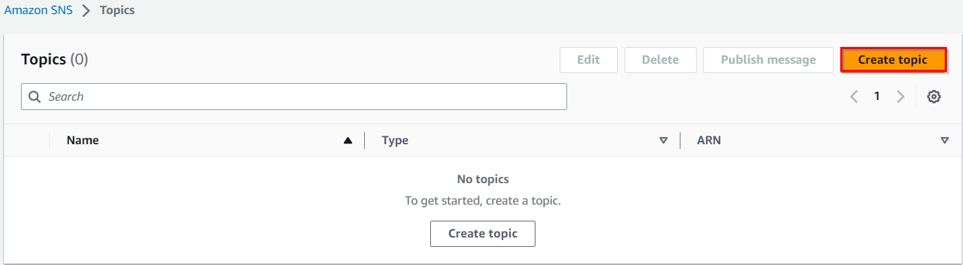

1. Select the Type as **Standard**.

Under **Details**:

* + 1. Name : Enter **MyServerMonitor**
    2. Display name : Enter **MyServerMonitor**

1. Leave other options as default and click on **Create topic** button.
2. An SNS topic is now created.

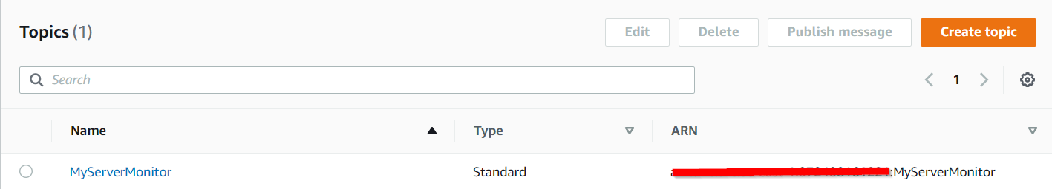

## **Task 4: Subscribe to SNS Topic**

In this task, we are going to subscribe to the SNS topic using an email address. By subscribing to the topic, you will receive email notifications whenever the subscribed topic publishes new messages. This step ensures that you will receive notifications for the events triggered in later steps.

1. Once SNS topic is created. Click on SNS topic **MyServerMonitor**.
2. Click on **Create Subscription** button.

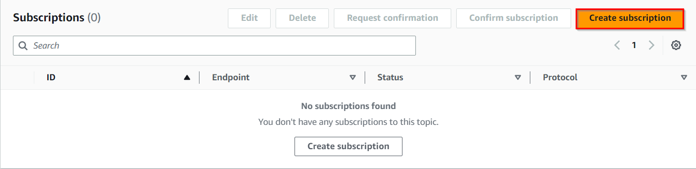

1. Under Details:
   1. Protocol : Select **Email**
   2. Endpoint : Enter your **<email address>**
   3. **Note:** Make sure you give a valid email address, as this is where you will receive SNS notifications.
   4. Click on **Create subscription** button.
2. You will receive an email confirming your subscription to your email address.

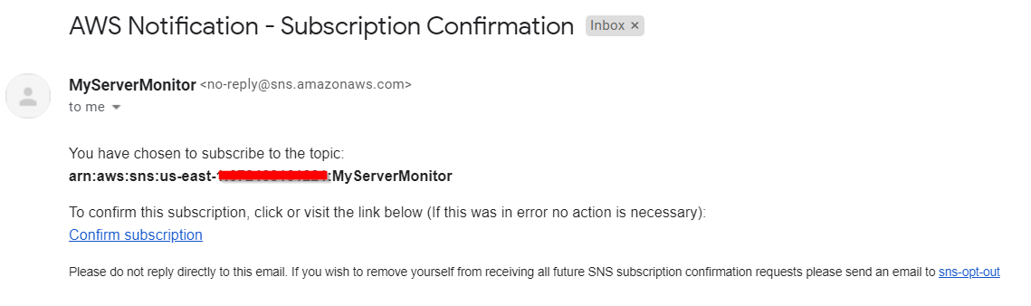

1. Click on **Confirm subscription**.

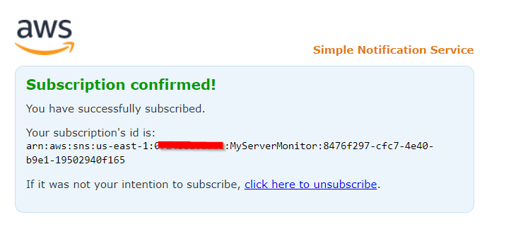

1. Your email address is now subscribed to the SNS Topic **MyServerMonitor**.

## **Task 5: Create CloudWatch Events**

In this task, we are going to create CloudWatch Events, which enable you to respond to changes in your AWS resources.

1. Navigate to **Services** and click on **Cloudwatch** under **Management & Governance.**
2. Navigate to **Events** in the left panel of the CloudWatch page.
3. Click on **Events** and select **Rules**.
4. You would see that it is redirecting towards **Amazon EventBridge** page.
5. Click on **Create rule** button.

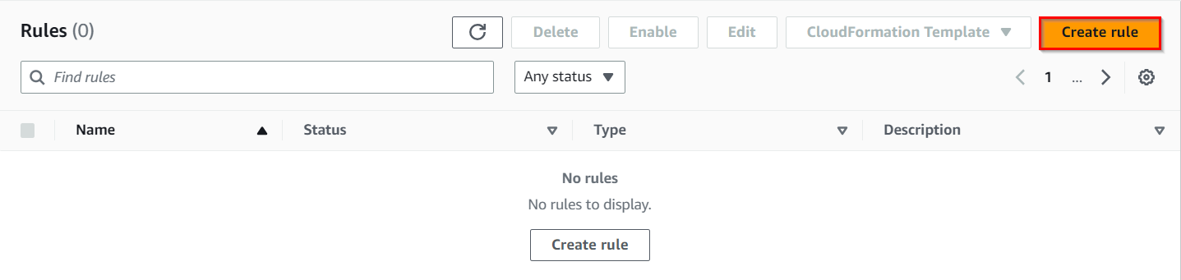

1. In Step1: **Define Rule detail**,

Name: Enter **MyEC2StateChangeEvent**

Description: Enter **MyEC2StateChangeEvent**

Rule Type : Select **Rule with an event pattern**

Click on **Next** button.

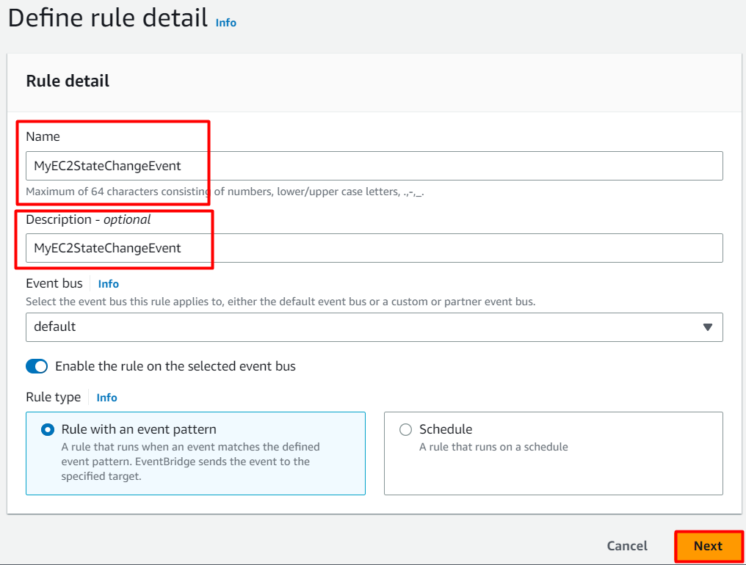

1. In Step2: **Build event pattern Page**,

Scroll down and Under **Event Pattern**:

AWS Service: Select **EC2**

Event Type: Choose **EC2 Instance State-change Notification**

No other changes required in this section.

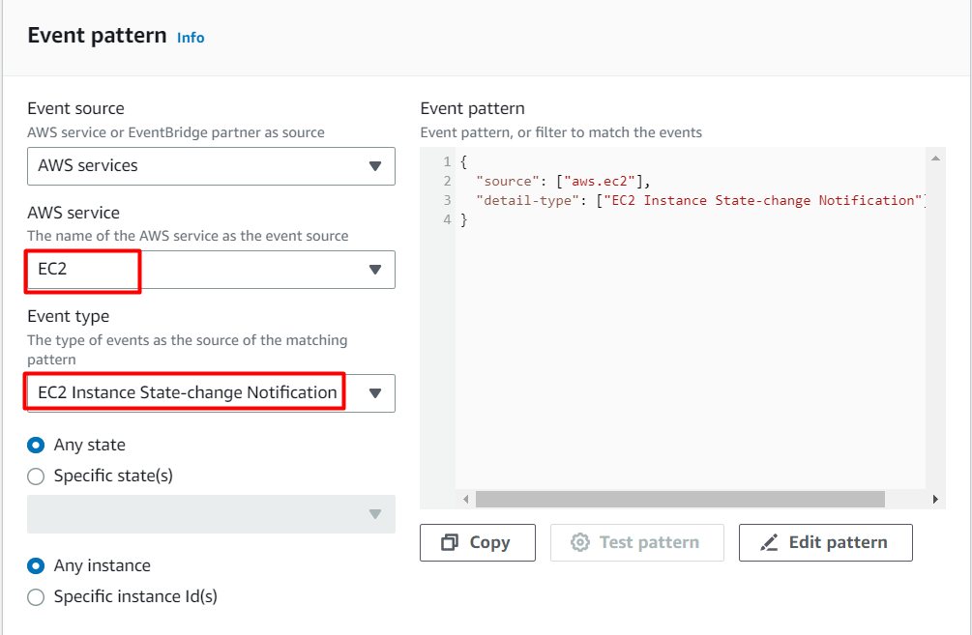

Click on **Next** button.

In Step3: **Select target(s)**,

Select a target: Select **SNS Topic from the target dropdown**

Topic: Select **MyServerMonitor**

Click on **Next** button.

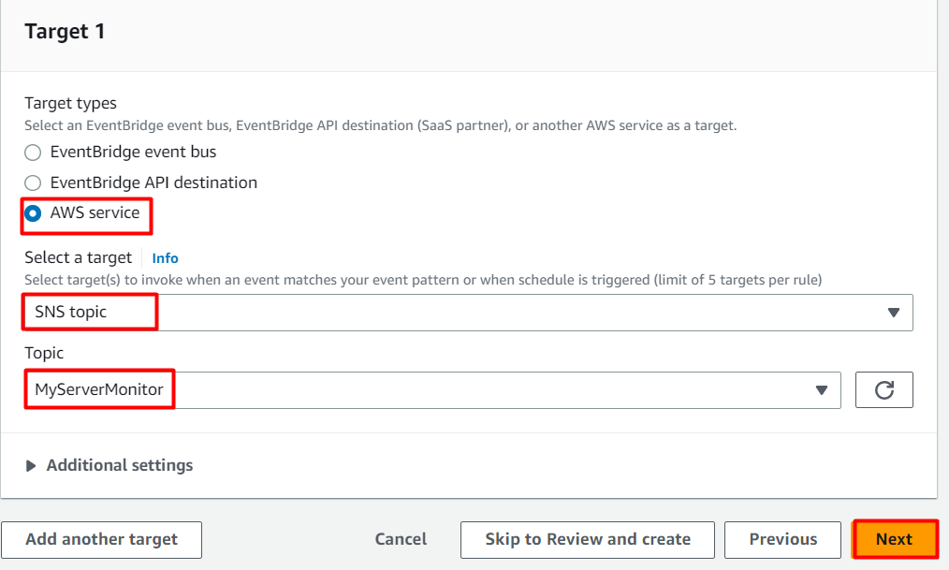

No changes required in Step 4, Click on **Next** button.

Review all the details and Click on **Create rule** button.

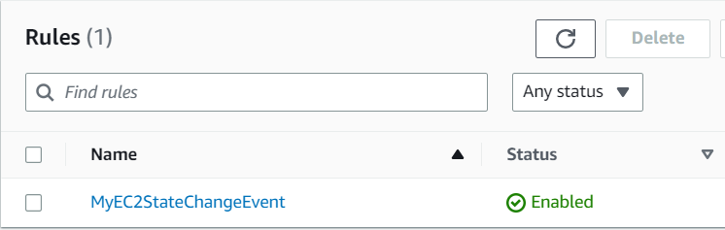

1. Now, every time the EC2 Server (MyEC2Server) is stopped or started up, an email notification is sent to the email address configured in the SNS Subscription.

## **Task 6: Test CloudWatch Event**

In this task, we are going to test the CloudWatch Events that you have set up. By stopping and starting the EC2 instance, you trigger state change events, which in turn trigger the CloudWatch Events. The purpose is to verify that the notifications are being sent to the subscribed email address correctly.

1. Navigate to the **EC2** Page in the AWS Management Console.
2. Click on **Instances** in the Left Panel.
3. Select the **MyEC2Server**. Click on **Instance state** and Click on **Stop instance**.

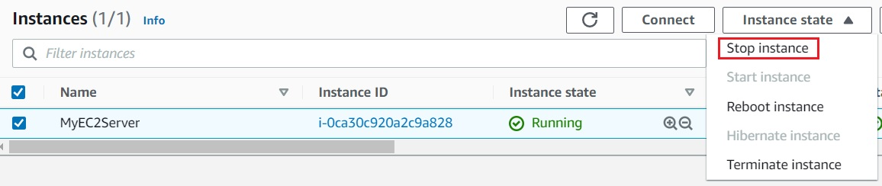

1. Click on **Stop** in the pop-up box.
2. Go back to your email address. You should have received some mail.

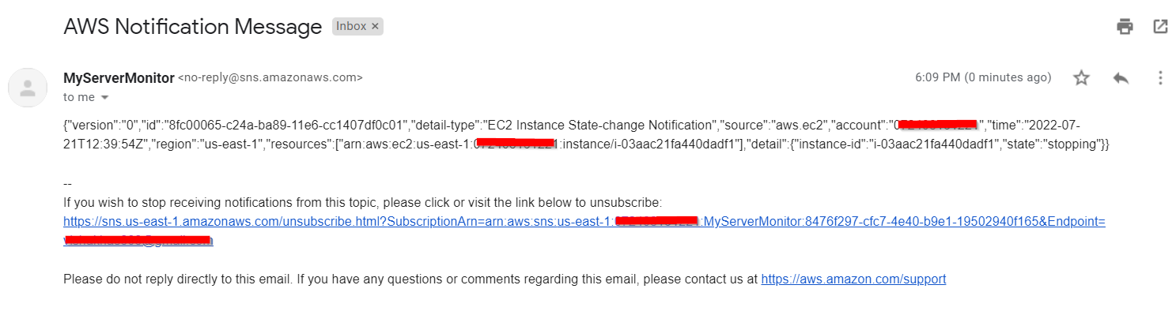

1. Two CloudWatch Event emails have been sent due to the **MyEC2Server** State changes. (stopping and stopped).
2. Navigate back to the **EC2** Page and **Start** the EC2 instance. You will receive another two emails for the state changes. (pending and running).

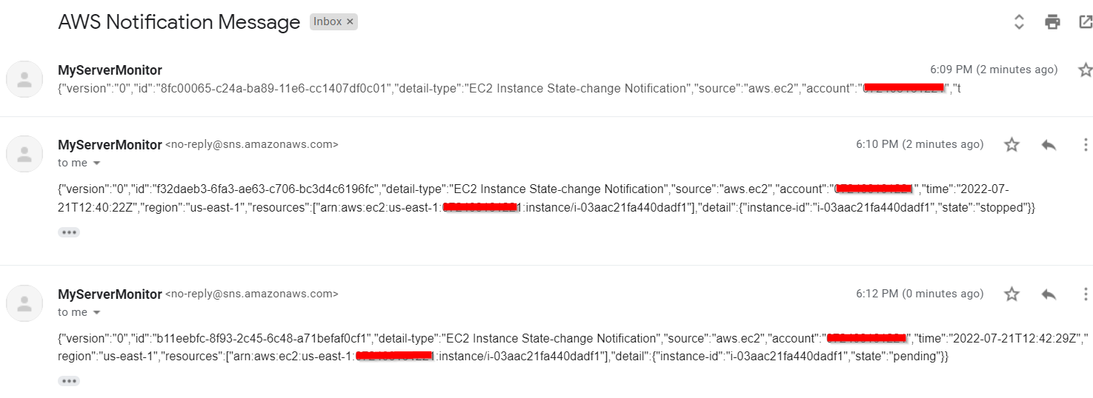

**Note: If you can't find the emails, check in SPAM folder of your email.**

1. You have successfully triggered CloudWatch Event SNS notification emails.
2. You can also create CloudWatch Event Notification for other AWS resources as well.

## **Do You Know?**

CloudWatch Events also integrates with AWS EventBridge, which is a serverless event bus service that makes it easy to build event-driven architectures. EventBridge extends the capabilities of CloudWatch Events by enabling cross-account event routing, transformation of events, and integration with third-party SaaS applications.